To complete the ISC - Proctored Test Deposit/Scheduling Form electronically:

- Move the scroll bar located on the far right of screen to locate and select the Fill & Sign Tab

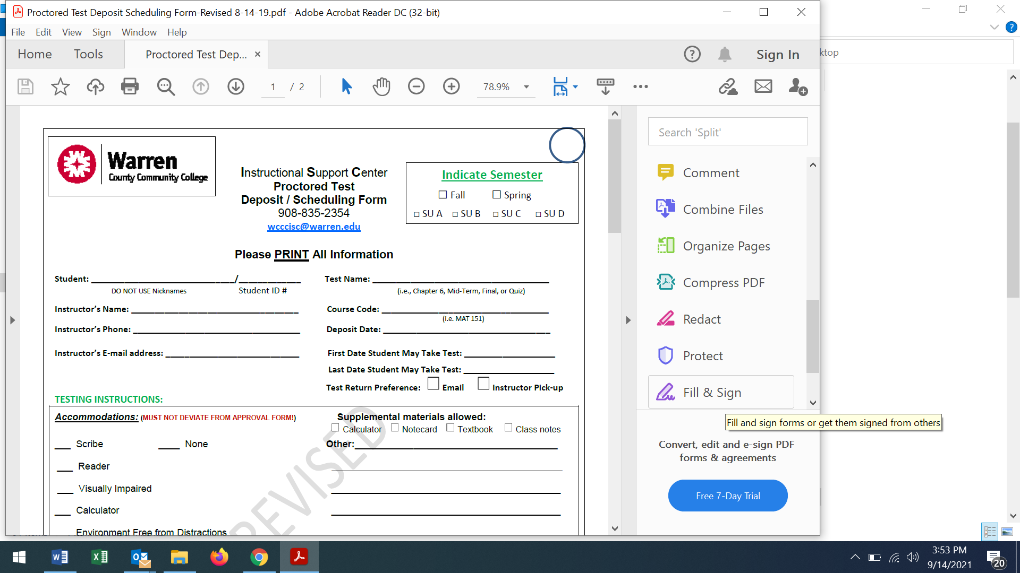

- Select “Fill and Sign” tab on this page, as well.

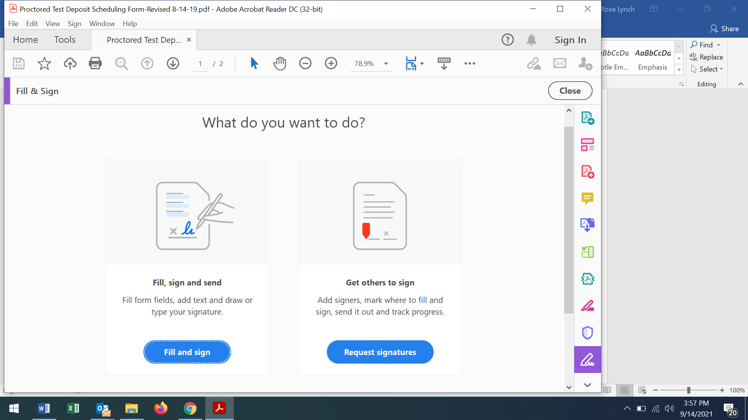

- Type your information in the document. To enter an or in a box within the document, you must first click on the or located above the form on the screen.

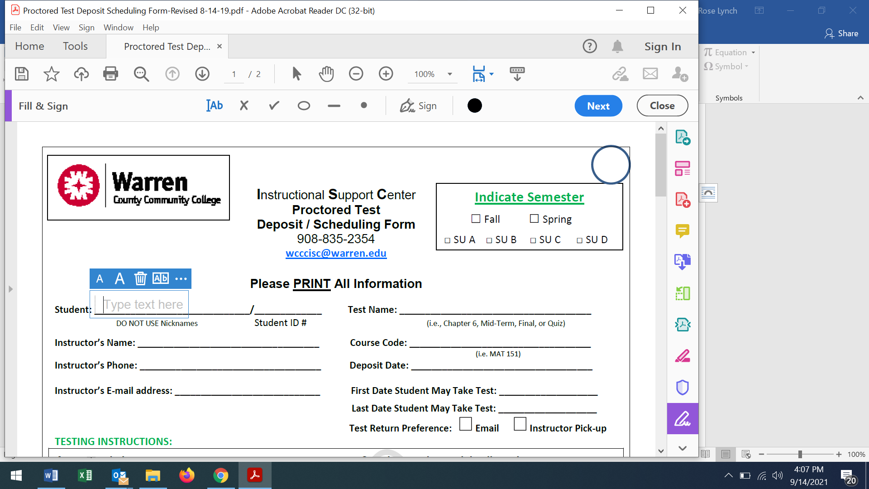

Be sure to include the following:
- Any and all approved accommodation information
- First & last dates student may take test
- Total time allotted for testing
- Your signature

Questions?
Please contact Rose Lynch at lynchr@warren.edu or (908) 835-2354.

