Why participate in the EOF Program?

EOF “On Track” Academic Support Model
“On Track” Model represents the key components and contributors to college success and completion. The four components include academic, social/personal, financial, and professional. The model informs the support services used and developed to meet student learning outcomes.
The EOF On Track Academic Support Model focuses on utilizing key campus tools/resources such as the EOF Coordinator, EOF Faculty Mentors, Academic Advisors, degree course sequence planning, advisement report, GPA calculator, and academic interventions.
EOF Program Grant funding

1st year students must attend fulltime (registered for 12 credits or more) in their 1st semester to qualify for EOF Program Acceptance. Grants are awarded for each semester.
- Full-time Maximum Annual / Semester
  - $1150 / $575
- Part-time (9 – 11 Credits)
  - $576 / $288
- Part-time (6-8 Credits)
  - $862 / $431
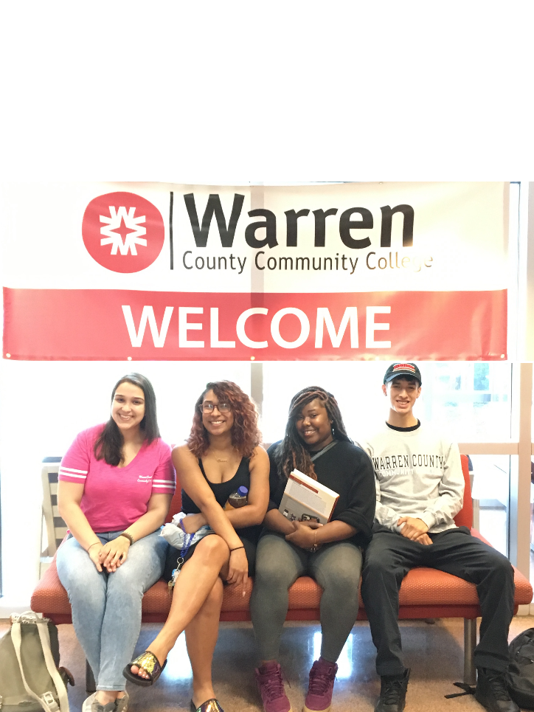
APPLY NOW! GET ACCEPTED!

Call Now (908) 835-2305
Meghan Cote, EOF Coordinator
or visit us on the web at
http://www.warren.edu/eof-scholarship-program/

Soar to New Heights, Become a Golden Eagle!

EDUCATIONAL OPPORTUNITY FUND (EOF) PROGRAM

475 Route 57 West
Washington, NJ 07882
(908) 835-9222
www.warren.edu
Educational Opportunity Fund (EOF) Program

The EOF Program at Warren County Community College’s purpose is to facilitate student transitions which lead to college readiness, positive adjustments, address developmental concerns, academic success, and student persistence to graduation.

APPLICATION PROCESS
(New Students)
- Complete a WCCC Admissions Application at www.warren.edu.
- Complete an EOF Application at http://www.warren.edu/eof-scholarship-program/ and submit via email to eofp@warren.edu.
- complete the FAFSA at www.fafsa.ed.gov. Contact Jacqueline Daly, Financial Aid Director for assistance at 908-835-2396 or jdaly@warren.edu
(Currently Enrolled WCCC Student)
Complete an EOF Application at http://www.warren.edu/eof-scholarship-program/
- Check WCCC Current Student enrollment status and enter total number of credits earned.
- Submit via email to eofp@warren.edu.

THE EOF ADVANTANGE

EOF Summer Scholars Bridge Program:
July 23rd – August 16th. Apply now! Acceptance is competitive and limited based on available funding resources.

Financial aid through state and federal grants, supplemental academic year as needed EOF funding support, and summer stipends

Personal Academic Advisor to help with course selection, college transitions, and academic support

Two (2) FREE college courses including books and school supplies through the Mandatory EOF Summer Scholars Bridge Program

Personal enrollment – to – graduation advisement, faculty mentors, and caring faculty, staff, and administrator who will support your journey to achieving your goals

Small group workshops on topics including: Study Skills 101, Improve Your Memory…Improve Your Grades, Surviving Exams: Effective Test Taking Strategies

Guided College Transfer and/or Career Planning and Advisement

FREE Tutoring, library literacy, and a supportive learning environment.

ELIGIBILITY REQUIREMENTS

- EOF Income Eligibility Requirements.
Family Size: Gross Income (not to exceed)
1 $24,120
2 $32,480
3 $40,840
4 $49,200
5 $57,560
6 $65,920
7 $74,280
8 $82,640
Add $8,360 for ea. Additional family member

2. Student must be a NJ resident for 12
consecutive months, prior to receiving
an EOF grant award.

EOF students will be expected to:
- Attend the Mandatory Summer Scholars Bridge Program
- Be a full-time student (12 credits)
- Maintain satisfactory academic progress (Min 2.0 GPA)
- Fully participate in EOF Program workshops, group advisement, early alert and student success programs

